CPSC 425: Assignment 4

Name: Terence Chen

Student number: 42602136

Q1) Nothing to hand in

Q2) Nothing to hand in

Q3)

Code changes in match function:

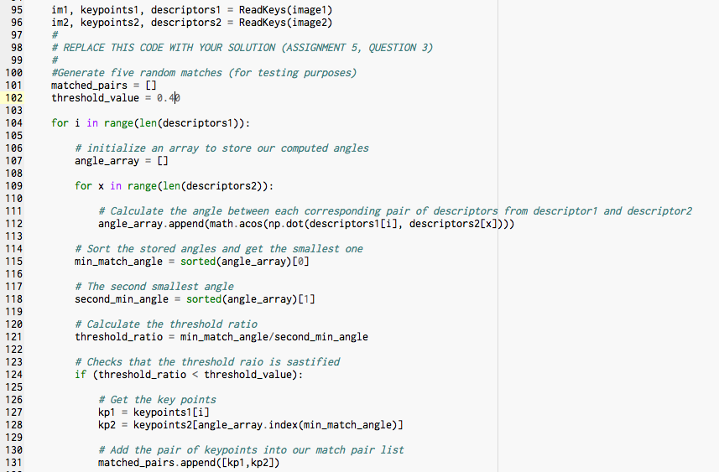

Result:

Chosen Threshold = 0.60

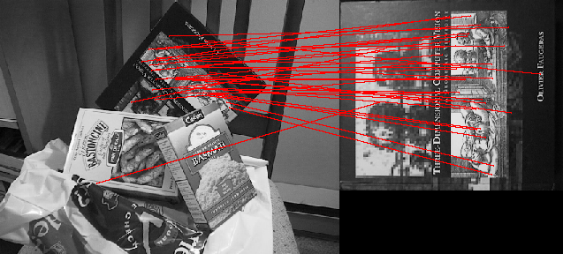

Test threshold = 0.80

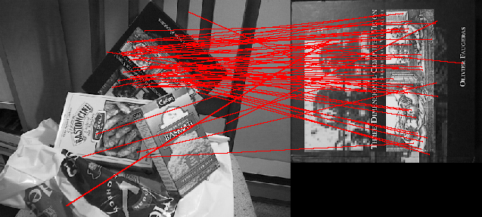

Test threshold = 0.40

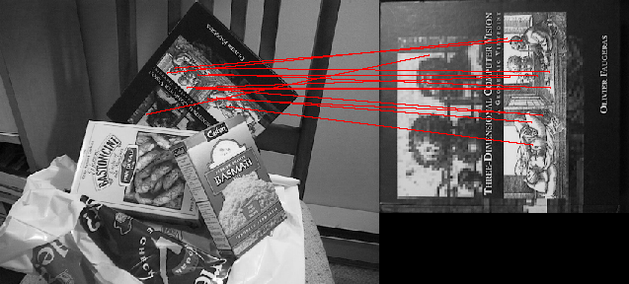

The threshold I chose for the book image was 0.60, its seems like around 0.60 we have a good amount of correct matches compared to the mismatches. When the threshold is 0.40, it seems like we a small amount but correct matches. Whereas for threshold = 0.80, we get more matches overall but more incorrect matches.

The threshold value was important as a low threshold yields good matches but in a small amount and a high threshold yielded more of matches with a lot of the matches being incorrect.

4)

Note: code is in the match function, more specifically below the code from question 3

Code:

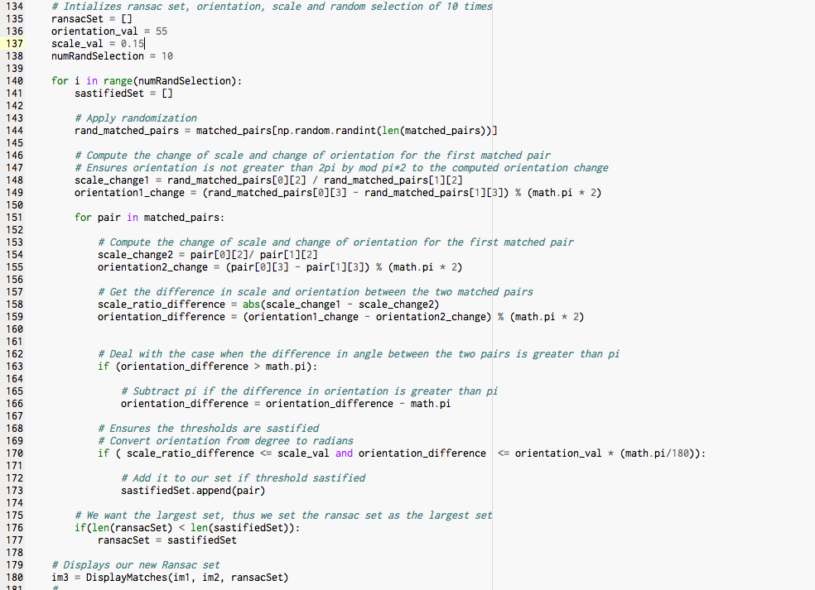

Result: orientation = 55 degrees and scale = 15%

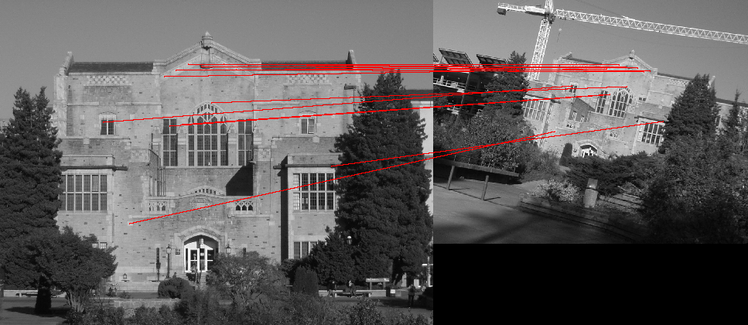

I found that changing the orientation threshold to around 55 degrees and scale threshold to 15% keeps the consistency of correct matches while keeping the outliers low. A higher threshold values yielded more overall matches but it also increases the number of outliers. Whereas a smaller threshold, yields less matches with more consistency incorrect matches.